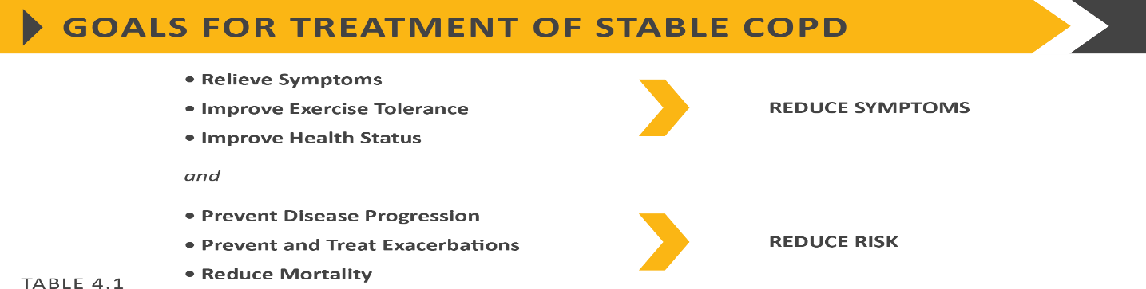
Summary of PHARMACOLOGICAL TREATMENT OF STABLE COPD - adaptado de GOLD 2020* Acessível em https://goldcopd.org/wp-content/uploads/2019/11/GOLD-2020-REPORT

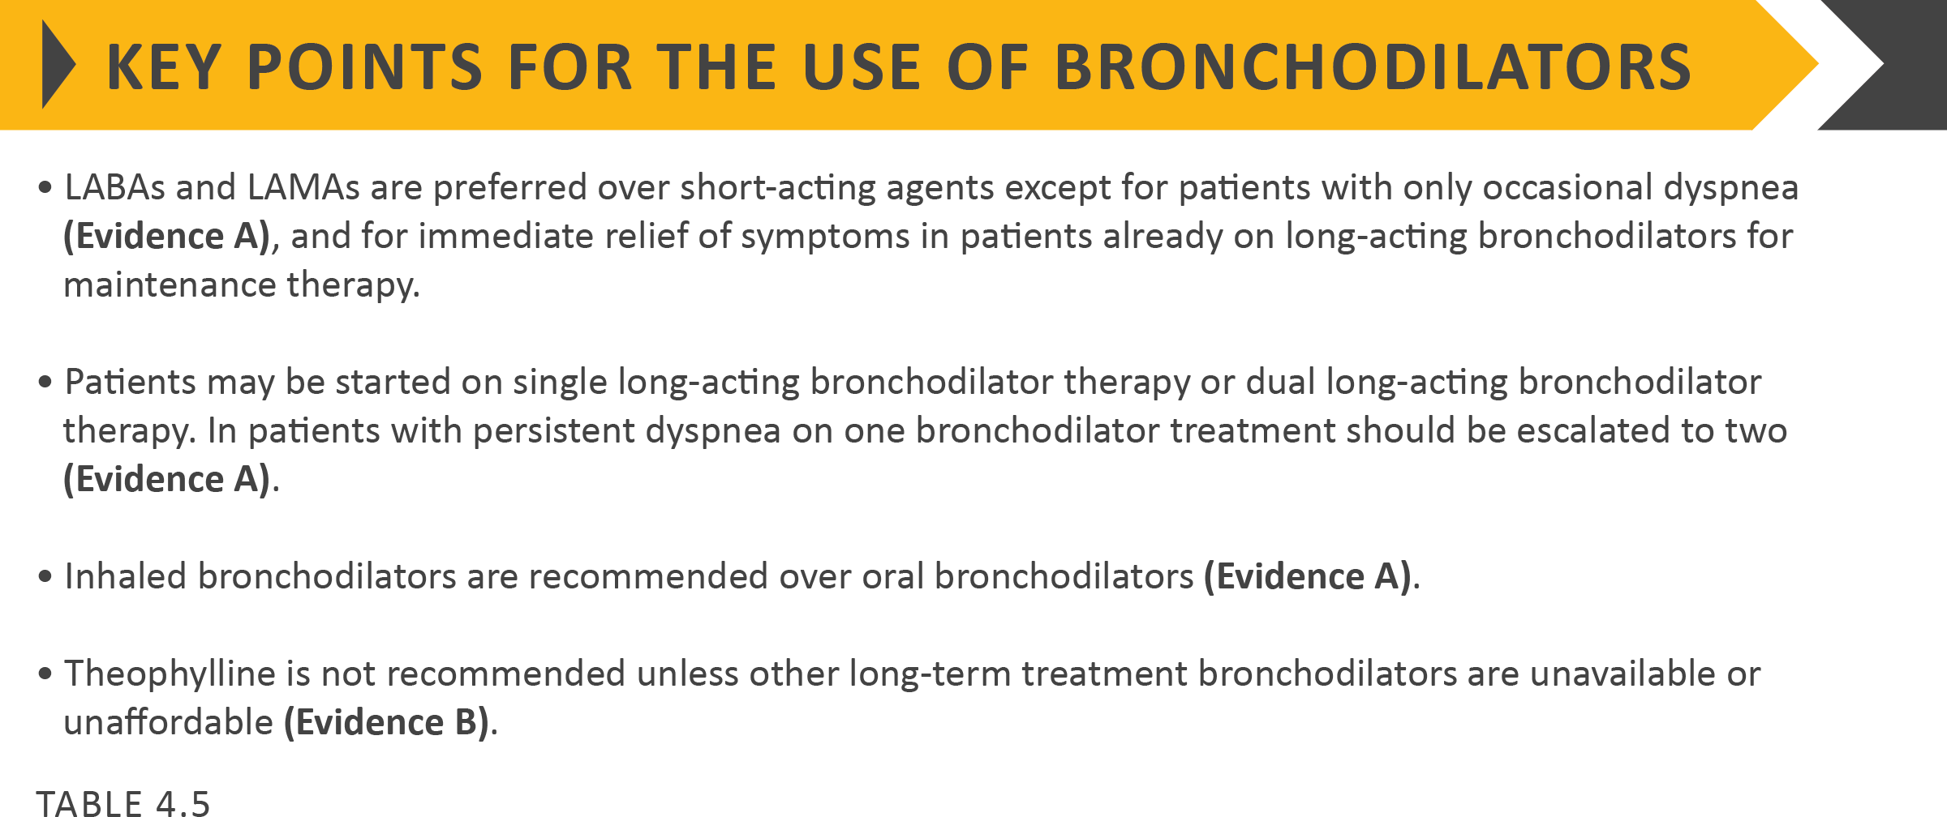

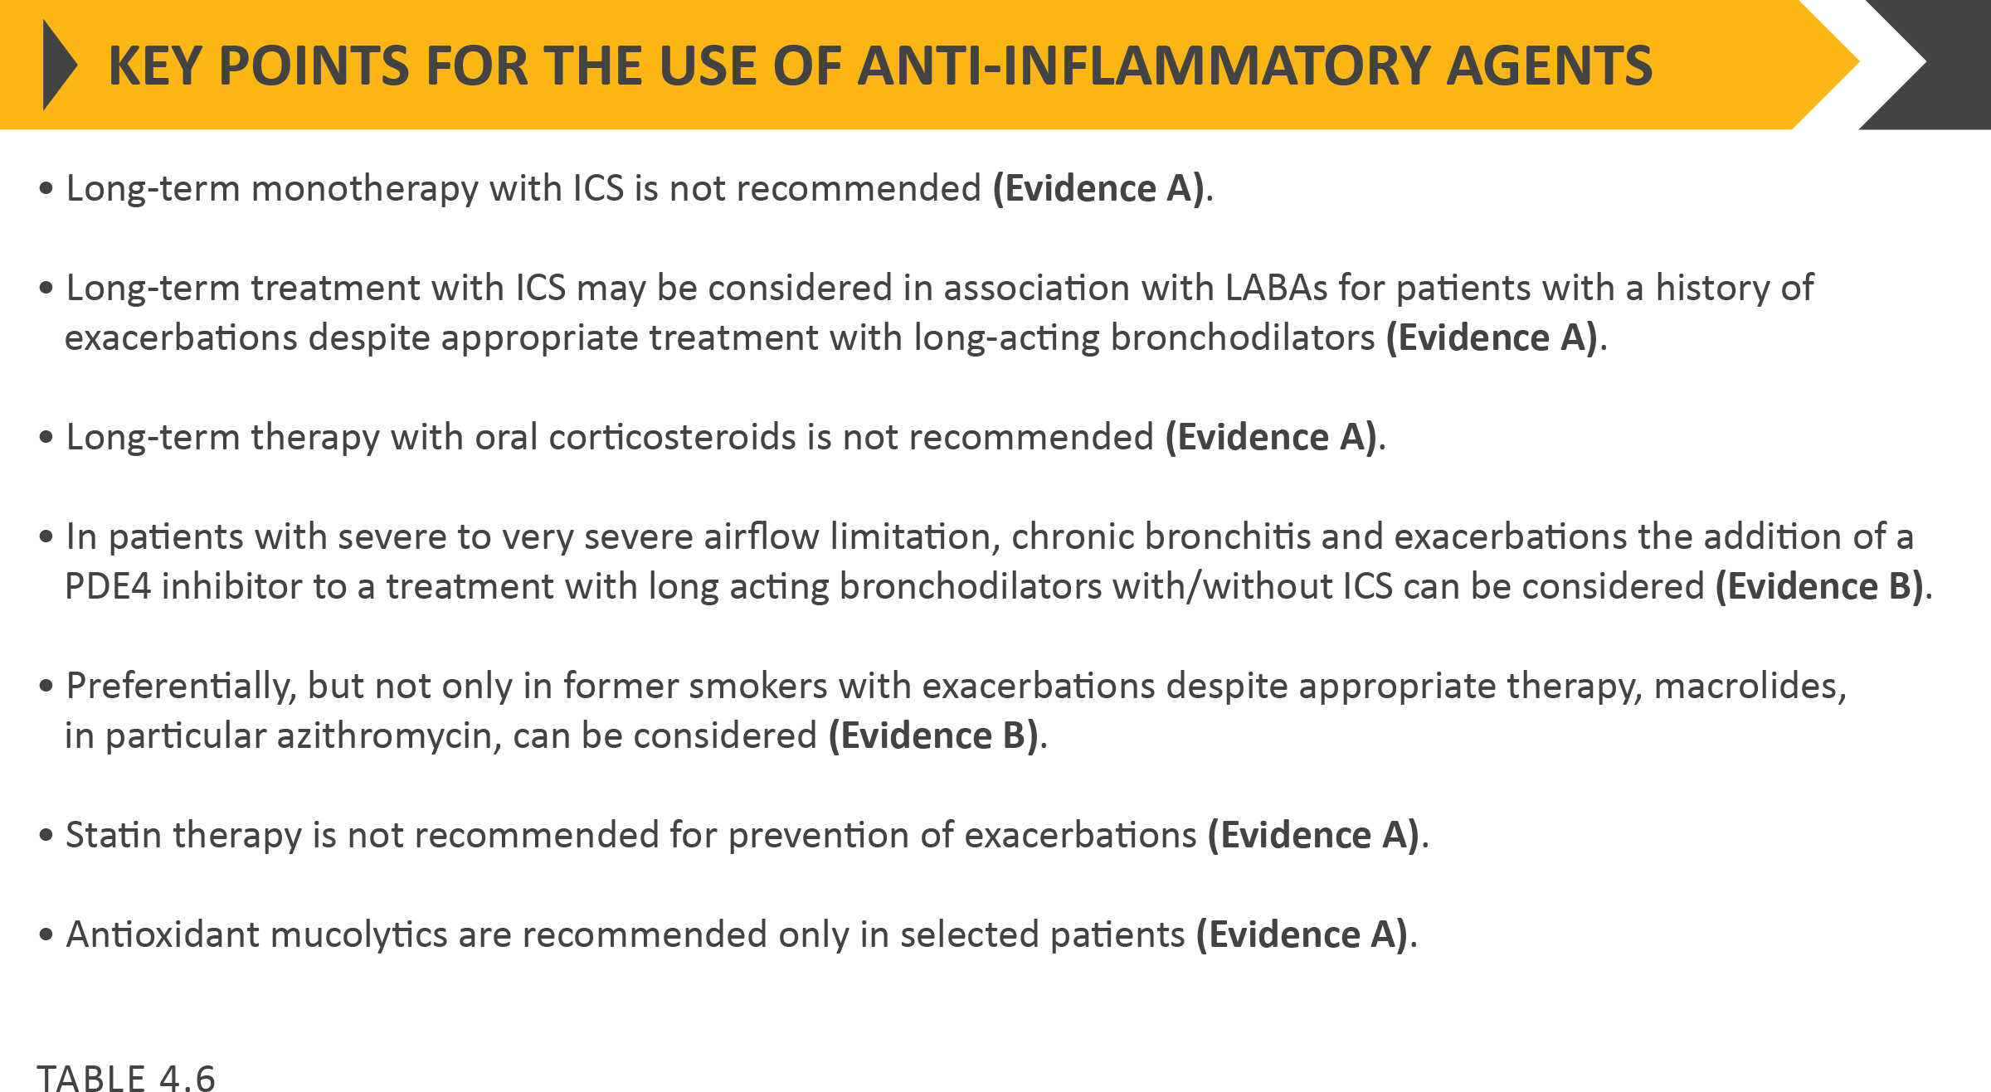

Definition of abbreviations: eos: blood eosinophil count in cells per microliter; mMRC: modified Medical Research Council dyspnea questionnaire; CAT™: COPD Assessment Test™.

Following implementation of therapy, patients should be reassessed for attainment of treatment goals and identification of any barriers for successful treatment. Following review of the patient response to treatment initiation, adjustments in pharmacological treatment may be needed.
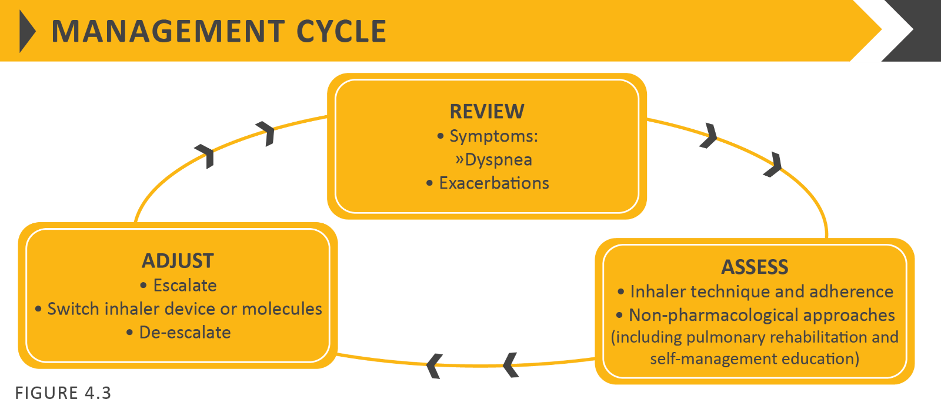

Algorithms for the assessment, initiation and follow-up management of pharmacological treatment

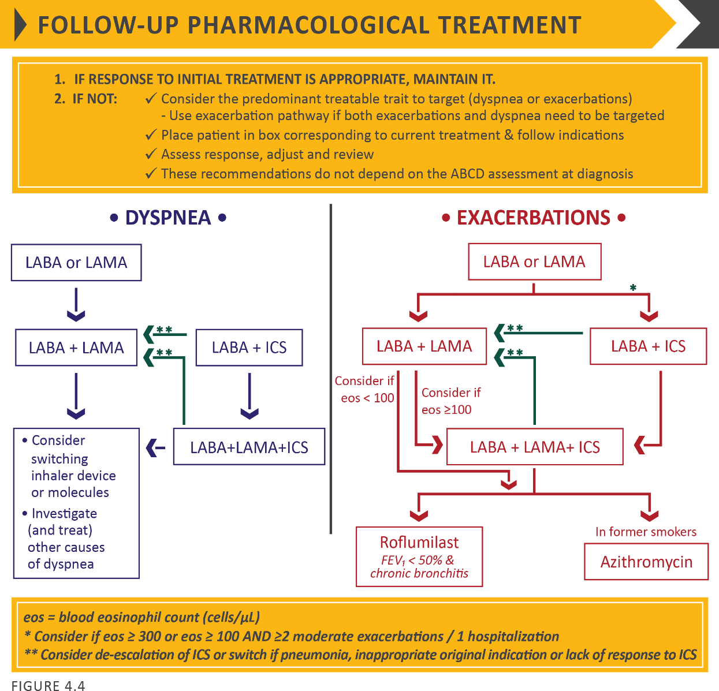
Escalation and de-escalation strategies based on available efficacy as well as safety data. The response to treatment escalation should always be reviewed, and de-escalation should be considered if there is a lack of clinical benefit and/or side effects occur.

De-escalation may also be considered in COPD patients receiving treatment who return with resolution of some symptoms that subsequently may require less therapy. Patients, in whom treatment modification is considered, in particular de-escalation, should be undertaken under close medical supervision.

We are fully aware that treatment escalation has not been systematically tested; trials of de-escalation are also limited and only include ICS.

Initial pharmacological management
Rescue short-acting bronchodilators should be prescribed to all patients for immediate symptom relief.

Group A
- All Group A patients should be offered bronchodilator treatment based on its effect on breathlessness. This can be either a short- or a long-acting bronchodilator.
- This should be continued if benefit is documented.

Group B
- Initial therapy should consist of a long acting bronchodilator. Long-acting inhaled bronchodilators are superior to short-acting bronchodilators taken as needed i.e., pro re nata (prn) and are therefore recommended.^{5,6}

- There is no evidence to recommend one class of long-acting bronchodilators over another for initial relief of symptoms in this group of patients. In the individual patient, the choice should depend on the patient’s perception of symptom relief.

- For patients with severe breathlessness initial therapy with two bronchodilators may be considered.⁷

- Group B patients are likely to have comorbidities that may add to their symptomatology and impact their prognosis, and these possibilities should be investigated.^{8,9}

Group C
- Initial therapy should consist of a single long acting bronchodilator. In two head-to-head comparisons^{10,11} the tested LAMA was superior to the LABA regarding exacerbation prevention, therefore we recommend starting therapy with a LAMA in this group.

Group D
- In general, therapy can be started with a LAMA as it has effects on both breathlessness and exacerbations.

- For patients with more severe symptoms (order of magnitude of CAT™ ≥ 20), especially driven by greater dyspnea and / or exercise limitation, LAMA/LABA may be chosen as initial treatment based on studies with patient reported outcomes as the primary endpoint where LABA/LAMA combinations showed superior results compared to the single substances. An advantage of LABA/LAMA over LAMA for exacerbation prevention has not been consistently demonstrated, so the decision to use LABA/LAMA as initial treatment should be guided by the level of symptoms.

- In some patients, initial therapy with LABA/ICS may be the first choice; this treatment has the greatest likelihood of reducing exacerbations in patients with blood eosinophil counts ≥ 300 cells/µL. LABA/ICS may also be first choice in COPD patients with a history of asthma.

- ICS may cause side effects such as pneumonia,^{10,12} so should be used as initial therapy only after the possible clinical benefits versus risks have been considered.

Dyspnea

- For patients with persistent breathlessness or exercise limitation on long acting bronchodilator monotherapy,¹³ the use of two bronchodilators is recommended.

  - If the addition of a second long acting bronchodilator does not improve symptoms, we suggest the treatment could be stepped down again to monotherapy. Switching inhaler device or molecules can also be considered.

- For patients with persistent breathlessness or exercise limitation on LABA/ICS treatment, LAMA can be added to escalate to triple therapy.

- Alternatively, switching from LABA/ICS to LABA/LAMA should be considered if the original indication for ICS was inappropriate (e.g., an ICS was used to treat symptoms in the absence of a history of exacerbations), or there has been a lack of response to ICS treatment, or if ICS side effects warrant discontinuation.

- At all stages, dyspnea due to other causes (not COPD) should be investigated and treated appropriately. Inhaler technique and adherence should be considered as causes of inadequate treatment response.

Exacerbations

- For patients with persistent exacerbations on long acting bronchodilator monotherapy, escalation to either LABA/LAMA or LABA/ICS is recommended. LABA/ICS may be preferred for patients with a history or findings suggestive of asthma. Blood eosinophil counts may identify patients with a greater likelihood of a beneficial response to ICS. For patients with one exacerbation per year, a peripheral blood level ≥ 300 eosinophils/µL identifies patients more likely to respond to LABA/ICS treatment.^{14,15} For patients with ≥ 2 moderate exacerbations per year or at least one severe exacerbation requiring hospitalization in the prior year, LABA/ICS treatment can be considered at blood eosinophil counts ≥ 100 cells/µL, as ICS effects are more pronounced in patients with greater exacerbation frequency and/or severity.¹⁶

- In patients who develop further exacerbations on LABA/LAMA therapy we suggest two alternative pathways. Blood eosinophil counts < 100 cells/µL can be used to predict a low likelihood of a beneficial ICS response:

  - Escalation to LABA/LAMA/ICS. A beneficial response after the addition of ICS may be observed at blood eosinophil counts ≥ 100 cells /µL, with a greater magnitude of response more likely with higher eosinophil counts.

  - Add roflumilast or azithromycin if blood eosinophils < 100 cells/µL.

- In patients who develop further exacerbations on LABA/ICS therapy, we recommend escalation to triple therapy by adding a LAMA.^{16,17} Alternatively, treatment can be switched to LABA/LAMA if there has been a lack of response to
ICS treatment, or if ICS side effects warrant discontinuation.

- If patients treated with LABA/LAMA/ICS who still have exacerbations the following options may be considered:

  - Add roflumilast. This may be considered in patients with an FEV₁ < 50% predicted and chronic bronchitis,¹⁸ particularly if they have experienced at least one hospitalization for an exacerbation in the previous year.^{19,20}
  - Add a macrolide. The best available evidence exists for the use of azithromycin, especially in those who are not current smokers.^{21,22} Consideration to the development of resistant organisms should be factored into decision-making.
  - Stopping ICS. This can be considered if there are adverse effects (such as pneumonia) or a reported lack of efficacy. However, a blood eosinophil count ≥ 300 cells /µL identifies patients with the greatest likelihood of experiencing more exacerbations after ICS withdrawal and who subsequently should be followed closely for relapse of exacerbations.^{23,24}

